**Assignment - 15 A Job Ready Bootcamp in C++, DSA and IOT**

Array and Functions in C Language

**1. Write a function to find the greatest number from the given array of any size. (TSRN)**

#include<stdio.h>

void greatestarray(int a[]);

int main()

{

int a[10],i,r;

printf("Enter data in array\n");

for(i=0;i<10;i++)

scanf("%d",&a[i]);

greatestarray(a);

return 0;

}

void greatestarray(int a[])

{

int gret=-1,i;

for(i=0;i<10;i++)

{

{

if(gret < a[i])

gret=a[i];

}

}

printf("%d ",gret);

}

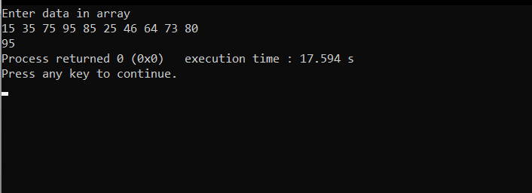

**2. Write a function to find the smallest number from the given array of any size. (TSRN)**

#include<stdio.h>

void smallestarray(int a[]);

int main()

{

int a[10],i,r;

printf("Enter data in array\n");

for(i=0;i<10;i++)

scanf("%d",&a[i]);

smallestarray(a);

return 0;

}

void smallestarray(int a[])

{

int small=99999,i;

for(i=0;i<10;i++)

{

{

if(small > a[i])

small = a[i];

}

}

printf("%d ",small);

}

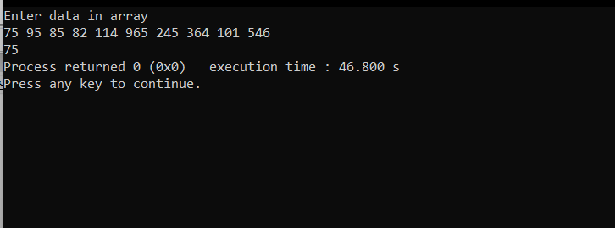

**3. Write a function to sort an array of any size. (TSRN)**

#include<stdio.h>

void sortarray(int a[]);

int main()

{

int a[10],i,r;

printf("Enter data in array\n");

for(i=0;i<10;i++)

scanf("%d",&a[i]);

sortarray(a);

return 0;

}

void sortarray(int a[])

{

int temp,i,j;

for(i=0;i<10;i++)

{

for(j=i+1;j<9;j++)

{

if(a[i]>a[j])

{

temp=a[i];

a[i]=a[j];

a[j]=temp;

}

}

}

for(i=0;i<10;i++)

printf("%d ",a[i]);

}

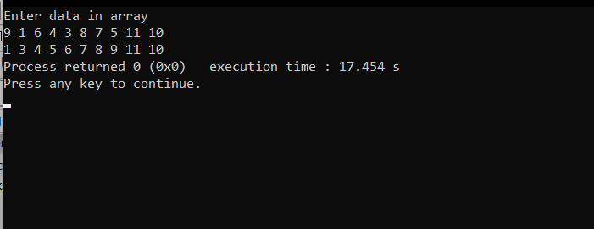

**4. Write a function to rotate an array by n position in d direction. The d is an indicative value for left or right. (For example, if array of size 5 is [32, 29, 40, 12, 70]; n is 2 and d is left, then the resulting array after left rotation 2 times is [40, 12, 70, 32, 29] )**

#include<stdio.h>

void rotatearray(int a[],int);

int main()

{

int a[10],i,r;

printf("Enter data in array\n");

for(i=0;i<10;i++)

scanf("%d",&a[i]);

printf("Enter how many will be perform ");

scanf("%d",&r);

rotatearray (a,r);

return 0;

}

void rotatearray (int a[],int r)

{

int temp=0,i,j;

for(j=0;j<r;j++)

{

temp=a[0];

for(i=0;i<10;i++)

{

a[i]=a[i+1];

}

a[9]=temp;

}

for(i=0;i<10;i++)

printf("%d ",a[i]);

}

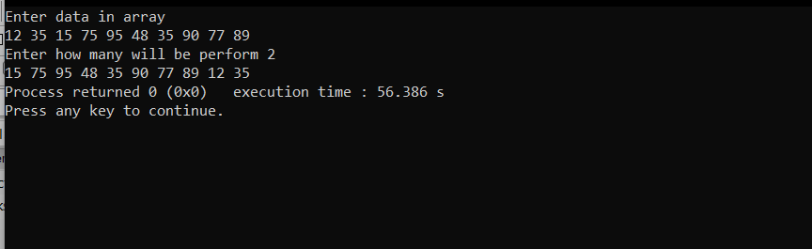

**5. Write a function to find the first occurrence of adjacent duplicate values in the array. Function has to return the value of the element.**

#include<stdio.h>

int duplicate(int a[]);

int main()

{

int a[10],i;

printf("Enter data in array\n");

for(i=0;i<10;i++)

scanf("%d",&a[i]);

printf("First duplicate no is %d",duplicate(a));

return 0;

}

int duplicate(int a[])

{

int i,j,result;

for(i=0;i<10;i++)

{

for(j=i+1;j<9;j++)

{

if(a[i]==a[j])

{

result=a[i];

return result;

}

}

}

}

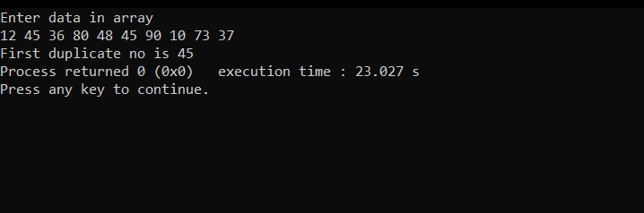

**6. Write a function in C to read n number of values in an array and display it in reverse order.**

#include<stdio.h>

void reversearray(int a[]);

int main()

{

int a[10],i;

printf("Enter data in array\n");

for(i=0;i<10;i++)

scanf("%d",&a[i]);

reversearray(a);

return 0;

}

void reversearray(int a[])

{

int i;

for(i=0;i<10;i++)

{

printf("%d ",a[9-i]);

}

}

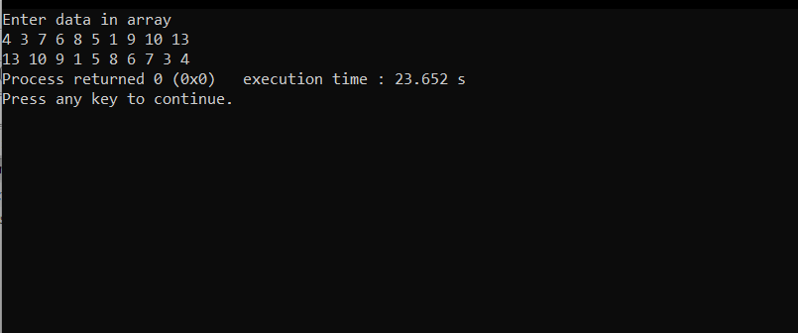

**7. Write a function in C to count a total number of duplicate elements in an array.**

#include<stdio.h>

int duplicate(int a[]);

int main()

{

int a[10],i;

printf("Enter data in array\n");

for(i=0;i<10;i++)

scanf("%d",&a[i]);

printf("total duplicate no is %d",duplicate(a));

return 0;

}

int duplicate(int a[])

{

int i,j,result=0;

for(i=0;i<10;i++)

{

for(j=i+1;j<10;j++)

{

if(a[i]==a[j])

{

result++;

}

}

}

return result;

}

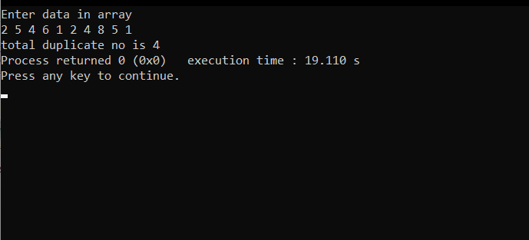

**8. Write a function in C to print all unique elements in an array.**

#include<stdio.h>

void unique(int a[]);

int main()

{

int a[10],i;

printf("Enter data in array\n");

for(i=0;i<10;i++)

scanf("%d",&a[i]);

unique(a);

return 0;

}

void unique(int a[])

{

int freq[100]={0},i;

for(i=0;i<10;i++)

{

freq[a[i]]++;

}

printf("Unique Element is\n");

for(i=0;i<100;i++)

{

if(freq[i]==1)

printf("%d\n",i);

}

}

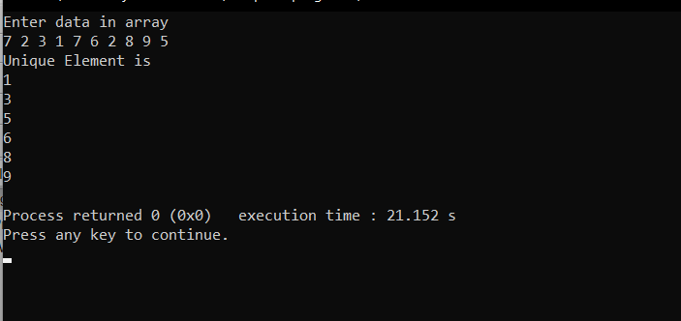

**9. Write a function in C to merge two arrays of the same size sorted in descending order.**

#include<stdio.h>

void mergearray(int a[],int b[]);

int main()

{

int a[10],i,b[10];

printf("Enter data in 1st array\n");

for(i=0;i<10;i++)

scanf("%d",&a[i]);

printf("Enter data in 2nd array\n");

for(i=0;i<10;i++)

scanf("%d",&b[i]);

mergearray(a,b);

return 0;

}

void mergearray(int a[],int b[])

{

int x[20],i,j,temp;

for(i=0;i<20;i++)

{

if(i<10)

x[i]=a[i];

else

x[i]=b[i-10];

}

for(i=0;i<20;i++)

{

for(j=i+1;j<20;j++)

{

if(x[i] < x[j])

{

temp=x[i];

x[i]=x[j];

x[j]=temp;

}

}

}

for(i=0;i<20;i++)

printf("%d ",x[i]);

}

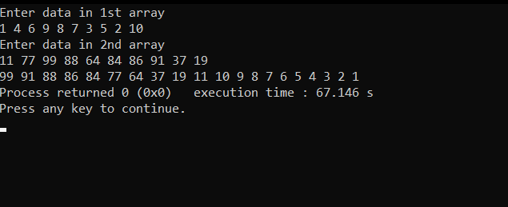

**10. Write a function in C to count the frequency of each element of an array**.

#include<stdio.h>

void frequency(int a[]);

int main()

{

int a[10],i;

printf("Enter data in array\n");

for(i=0;i<10;i++)

scanf("%d",&a[i]);

frequency(a);

return 0;

}

void frequency(int a[])

{

int freq[100]={0},i;

for(i=0;i<10;i++)

{

freq[a[i]]++;

}

printf("Frequency of Each Element is\n");

for(i=0;i<100;i++)

{

if(freq[i]!=0)

printf("%d ==> %d\n",i,freq[i]);

}

}

